Published in: *Natura w Sztuce – Nature in Art*, Kraków: MOCAK Museum of Contemporary Art in Krakow 2019, 20–39

**Wolfgang Welsch**

***Art versus Nature?***

**Opposites, unity or interpenetration?**

There are three different ways to view the relationship between art and nature.

The first perspective is *dualistic*: art and nature are in clear contrast. Nature is the original sphere. Human culture is becoming more and more distinct from it, and this reaches its peak in human art, which is autonomous and thus follows only its own laws and no longer any imperatives of nature.

A second view – the *monistic* one – claims in contrast that human culture is nothing more than a continuation of nature and still a part of it. Nothing escapes nature. It is naturalism and not culturalism that has it right. Aesthetics and art are already to be found in the animal kingdom – their human equivalents are merely continuations created by an animal called homo sapiens.

The third attitude does not take a clear stance either way, rather representing an *integrative* viewpoint. Nature and culture are indubitably to some extent mutually autonomous, yet each is capable of having an impact on and penetrating the other. The truth lies neither with a simple dualism or monism but with amalgamations; nature and art repeatedly influence and cross-fertilize each other.

Today, as has indeed been the case for a long time, this third approach has taken the lead. We constantly refine our understanding of how human culture has developed from previous achievements of natural evolution, how culture originated already in the animal kingdom, and how human cognition grew out of the cognition of the primates, or how human morality has drawn on animal altruism and refined it. But we also perceive more and more clearly how much our culture has been affecting and changing nature. Earlier and welcome examples of this are agriculture or the creation and maintenance of gardens. Contemporary evidence, on the other hand, is rather frightening: capitalist technology causes environmental destruction, climate change and the extinction of numerous life forms. Today, humankind has left its mark throughout the natural world. The new epoch is referred to as the Anthropocene.[1] Nature has lost its innocence, and culture its nobility. The two do not embody different orders, but prove to be increasingly interlinked and intertwined. Man, who has emerged from nature, has fundamentally changed nature’s state and course.

**The traditional continuum thesis: art as imitation of nature**

As regards the relationship between nature and art, for centuries there prevailed in European culture the view that art is, or should be, an emulation of nature. What art depicts should exhibit the greatest possible verisimilitude. In his *Naturalis Historia*, Pliny the Elder quotes an anecdote that illustrates this point perfectly: the Greek painter Zeuxis (5th century BC) ‘produced a picture of grapes so successfully represented that birds flew up to the stage-buildings; whereupon Parrhasius [another painter from the same period] produced such a realistic picture of a curtain that Zeuxis, proud of the verdict of the birds, requested that the curtain should now be drawn and the picture displayed; and when he realized his mistake, with a modesty that [...] did him honour he yielded up the prize, saying that whereas he had deceived birds Parrhasius had deceived him, an artist.’[2] Nature sets the norm, and art is to match it.[3]

In the Renaissance, this idea of continuity was even vested with a justification referring to the origins of art. Leone Battista Alberti declared that art was an imitation of nature because it was nature that yielded the very first representations. Art is primordially a natural product, for nature itself sometimes creates figurative representations – ‘in the cut faces of marble she often paints centaurs and faces of bearded and curly headed kings’[4] – and it is from the observation of such phenomena that painting and sculpture arose.[5]

If that is so, then of course there is no contradiction from the ground up, but a continuity between nature and art. Art is originally a product of reality itself.[6] Art is rooted in nature.

**A cultural protest: imitation is a mere copycat game – art must transcend nature**

**and be autonomous**

Soon, however, the thesis that art depends on nature evoked cultural protest: mere imitation of nature is not enough; art needs spirituality and has to be governed by its own, autonomous laws – not by the laws of nature.

As it happens, the theoreticians of imitation themselves took the first step in that direction. What they postulated was not direct realism; instead improvements aimed at creating an ideal work were permitted – and desirable. When Zeuxis was commissioned by the inhabitants of Crotona to paint the portrait of Helen, the incarnation of female beauty, he ‘did not think that he could find all the component parts of perfect beauty in one person, because nature has made nothing of any class absolutely perfect in every part.’ So, instead of one model, he selected five, taking the finest feature of each to create a composite image of ideal beauty.[7] And Aristotle, the paradigm theoretician of imitation, wrote: ‛if it is impossible that there be such people as Zeuxis painted, then he painted them for the better, for the exemplary has to surpass reality.’[8] It is not nature as it actually exists, but its essence and ideal that sets the standard.

In the late Middle Ages and the early time of the modern era mimesis came to be criticized with increasing severity. It was discredited as no more than just ‘aping’. Apes became popular as a caricature of painters who were content with just a simple imitation. The intention was to show that such imitation was not befitting for humans – that it was no more than a ‘childish pastime’, thoughtless ‘aping’.[9] On the other hand, a form of art higher than imitation was brought into play: the art of invention. To illustrate it, the German Renaissance philosopher Nicholas of Cusa used the example of making a wooden spoon. He had the layman who crafts such spoon say: ‛A spoon has no other exemplar except our mind’s idea [of the spoon]. [...]in my [work] I do not imitate the visible form of any natural object, for such forms of spoons, dishes, and jars are perfected by human artistry alone. So my artistry involves the perfecting, rather than the imitating, of created visible forms, and in this respect it is more similar to the Infinite Art.’[10] – So on the one hand imitation was discredited as mere aping, and on the other hand the new ideal of artistic creativity was established. Art departed from the laws of nature and gained autonomy.[11]

Nevertheless, there still persisted a certain tension between art’s attachment to nature on the one hand and its autonomy on the other. While mere imitation no longer sufficed, creative freedom carried the danger of succumbing to subjective mannerisms. Therefore geniuses such as Leonardo, Diderot and Kant repeatedly emphasized art’s connectedness to nature. Leonardo granted painting supremacy over other arts, since – unlike the others – it did not falsify nature.[12] Diderot claimed that faithful representation was the highest virtue in art.[13] And Kant made the verisimilitude the criterion of artistic success: ‘Beautiful Art is an art insofar as it seems at the same time to be nature’.[14]

Such toing and froing between natural bonds and independence from nature will continue as long as nature and culture are considered two distinct spheres. If nature is considered the opposite of culture, then it will inevitably be the object of both longing and rejection – therefore art will forever swing between submission to nature and its own sovereignty. A change will come only when we begin to understand nature and culture not as opposites but as a continuum and when therefore art and aesthetics can be viewed as emerging products of nature.

**The evolutionary continuum between nature and art**

This perspective gained ground in the 19th century in the wake of Charles Darwin’s theory of evolution and of his and Ernst Haeckel’s concept of evolutionary aesthetics.

Haeckel, who propagated Darwin in German-speaking countries, was fascinated by the wealth of natural beauty. Nature produces formations of extraordinary beauty that are to be acknowledged as models for art. In the *Preface* to his *Art Forms in Nature*,[15] Haeckel wrote: ‘Nature has produced in its womb an inexhaustible wealth of wonderful creatures, which in their beauty and diversity far exceed all the art forms ever created by the mankind’.[16]

Haeckel’s drawings for the book demonstrated his point. The work had a tremendous influence on contemporary art, for example such art nouveau artists as Hermann Obrist, Joseph Maria Olbrich, August Endell and Louis Comfort Tiffany. Haeckel’s plates even inspired the famous portal that René Binet designed for the World Exhibition in Paris in 1900.[17] In the face of nature’s art forms, art must no longer distance itself from nature, but can follow it, be inspired by it, continue the work of nature.

Haeckel not only admired the beauty of nature, but also understood that nature drives itself forward through its artistic production, that art production is in fact a process of reality’s self-enhancement. Thus the old antithesis between reality and art was blown away. Art is a strategy of nature itself. Art does not stand in opposition to nature, but stems from it and is inherent in it.

Darwin went a step further. He maintained that it was not only miraculously beautiful creations that came from nature, but also *aesthetic attitude* and *aesthetic sense*. The second volume of Darwin’s *Descent of Man*, published in 1871, demonstrates that aesthetics was born in the animal kingdom and did not first appear with humans. Darwin develops a theory of sexual selection that transcends natural selection. Aesthetically attractive features of one sex evoke excitement in the other sex, which leads to an aesthetically determined choice of partner for mating and reproduction. Sexual selection is no longer based on strength and struggle (as was the case in the regime of natural selection), but on aesthetic sense and aesthetic preferences.[18]

According to Darwin, aesthetics is therefore not a specifically cultural achievement (which as such could be contrasted with the natural), but is from the ground up a natural product. And it does not only belong to nature, but is a way in which nature reproduces, shapes and enhances itself. The progressive evolution of species advances through aesthetic refinements and decisions. Aesthetics is an active and productive factor of reality, an agent of further biological evolution. It was a great mistake to assume that the aesthetic sphere would be opposed to reality. On the contrary, it is from the outset a dimension of reality itself.[19]

Alberti spoke only of the appearance of representations in nature. Haeckel and Darwin dug much deeper. They teach us to recognize beauty production and beauty appreciation – i.e. art and aesthetics – as strategies already of nature, and not something that only appeared with the world of human culture. The gap between nature and culture has been bridged.

**Artistic interest in the reappearance of nature in culture**

Again and again, art is interested in phenomena that testify to the emergence of art in the midst of nature or, conversely, to the emergence of nature in the midst of culture. This is the stuff that fills the cabinets of wonder. Suitable samples are, for instance, atavisms – traits that disappeared many generations ago in the development of a species, suddenly reappear in an individual. These can be, for example, full facial and body hair, a gill slit at the neck, or surplus nipples and full beards in women.

[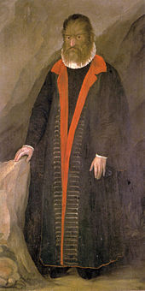](https://de.wikipedia.org/wiki/Datei:PetrusGonsalvus.jpg)

unknown German painter, *Pedro Gonsalvus*, c. 1580, Kunsthistorisches Museum Vienna [Ambras Castle],

inv. no. 8329

Such phenomena are considered curiosities. And they evoke the interest of artists, for in such cases – just as art and aesthetics are, according to the theory of evolution, a product of nature – traits of old nature emerge anew in the midst of civilization. A well-known example triad can be found in the cabinet of art and wonders at Ambras Castle: depictions of Pedro Gonsalvus and two of his children. Pedro (c. 1537–1618) had abnormal hair growth. At the age of ten he was taken to the court of the French King Henry II as a ‛wolf man’ or ‛monkey man’. When Pedro (who was by no means mentally retarded, he even spoke Latin) married, some children were born who also had abnormal body hair.

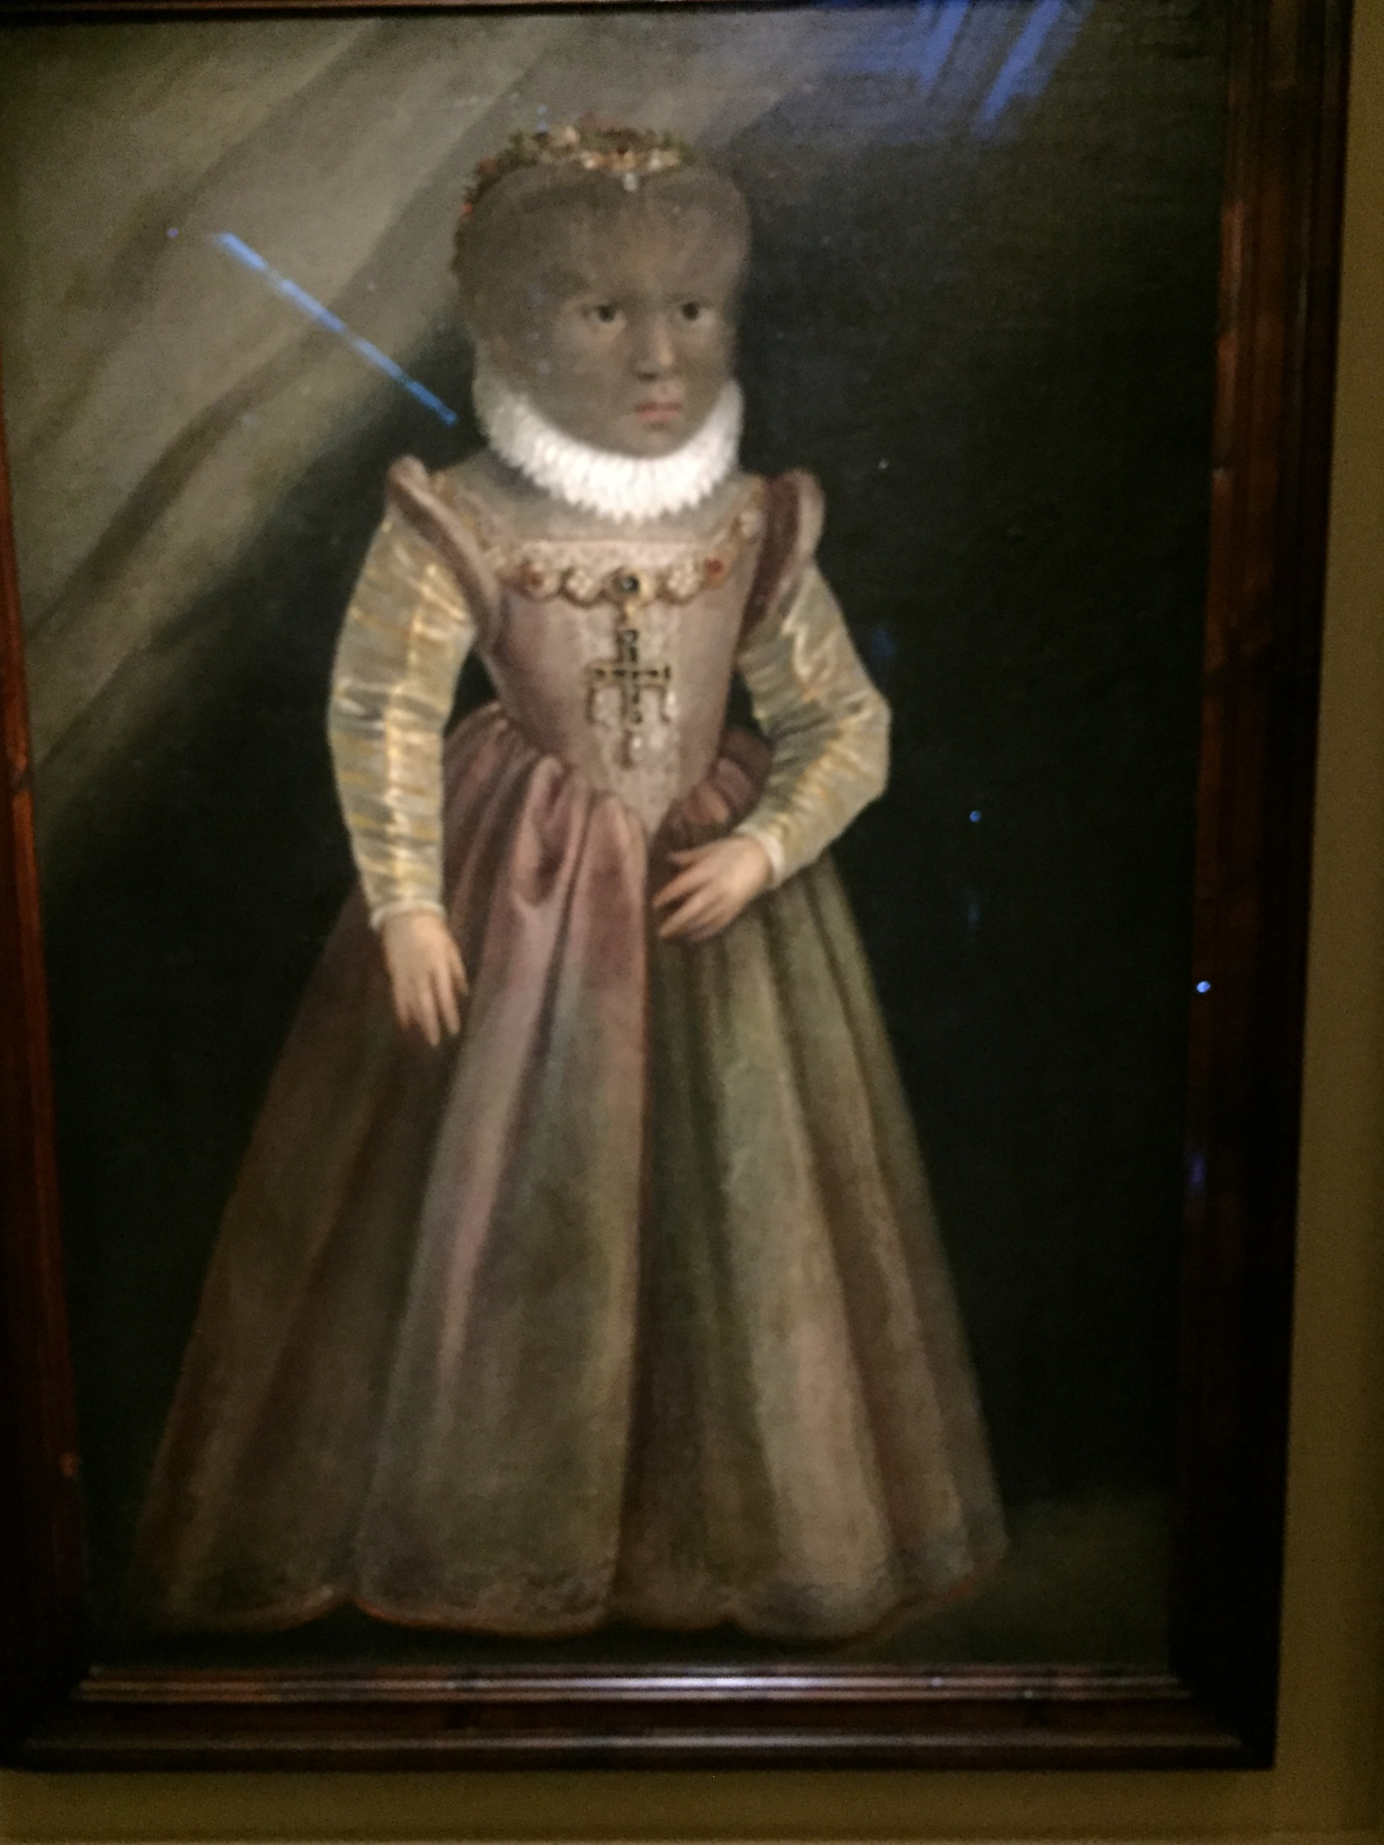 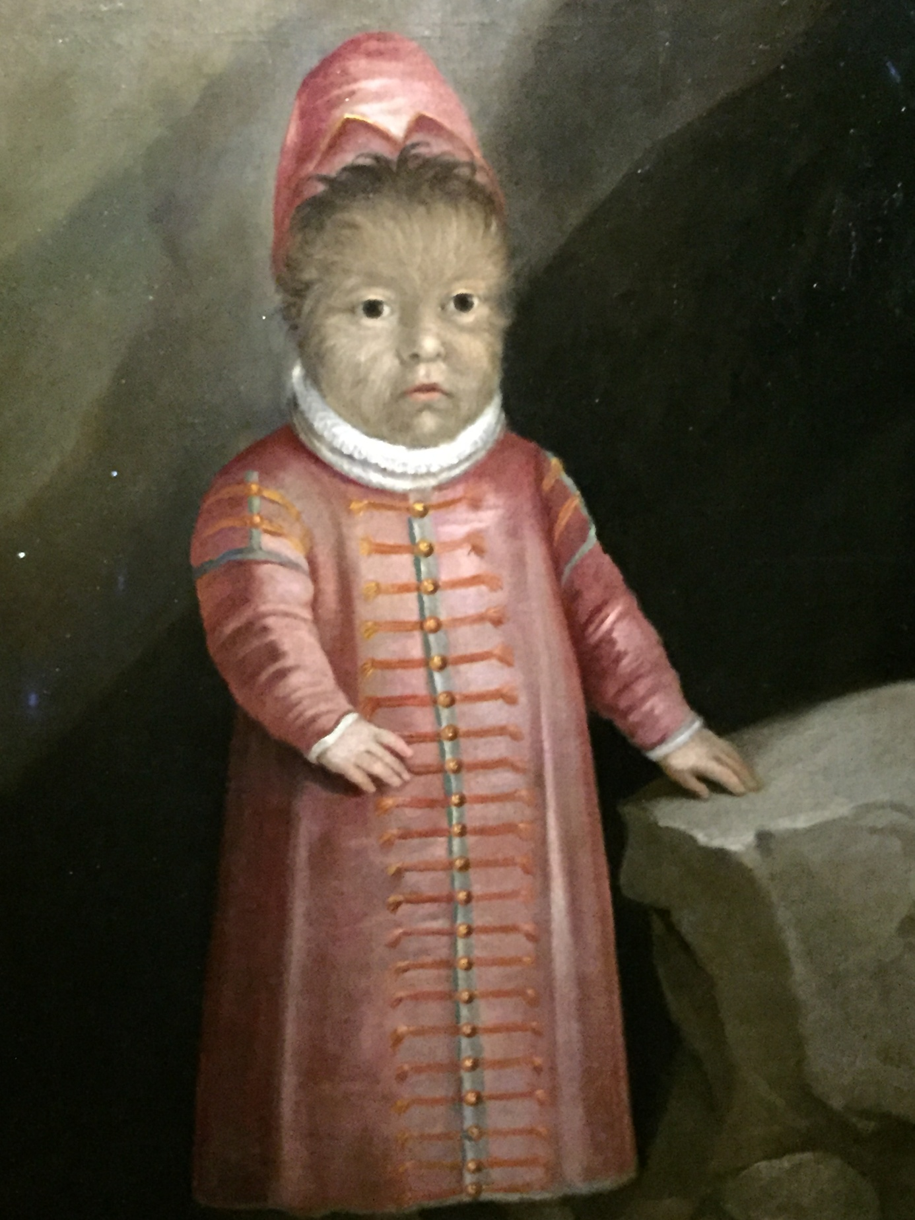

unknown German painter, *Madeleine Gonsalvus,* unknown German painter, *Son of PetrusGonsalvus*,

*Daughter of Petrus Gonsalvus*, c. 1580, c. 1580, Kunsthistorisches Museum Vienna

Kunsthistorisches Museum Vienna [Ambras Castle], [Ambras Castle], inv. no. 8332

inv. no. 8331

Already in the Middle Ages and Renaissance – when the special position of man became problematic in view of anatomical and behavioral similarities to animals – such cases attracted the attention of alert minds and the interest of artists.[20] They did all the more so after the advent of Darwin’s theory of evolution.

**Modern nature: an amalgam of nature and culture**

But of course: in view of the introductory remarks and the growing insight into the affiliation of nature and culture, such an emphasis on the role of nature in the midst of culture must at the same time be regarded as one-sided.

A counter-calculation is required. *Historically*, we find it in the appreciation of landscape; *theoretically* in the work of Konrad Fiedler; and *artistically*, for example, in the work of Giuseppe Penone.

When we delight in *landscapes*, we may talk much about the value and beauty of nature, but the truth is that the landscapes we appreciate have long since been altered by us humans. We admire, for example, the harmonious appearance of a landscape – and yet our point of reference is not simply raw, but cultivated nature: i.e. the balance between woodland and cultivated land, the pattern formation of the agrarian land that clings to the hills, the regulated course of the river, which results in a harmony of landscape and settlement. Several predicates and formulas for natural beauty refer precisely to cultivated nature, while ‘raw’ nature is perceived as repulsive.[21] Human cultural activity has been inscribed over and over again in what we refer to as ‘nature’.[22]

And art plays a significant role in this transformation of culture, as is perfectly exemplified by the English landscape garden. For what is its artificial design based on, which aims at making everything appear like nature? The 18th-century English landscape gardens were modeled not on nature, but on art: they drew their inspiration from 17th-century landscape paintings, especially those by Claude Lorrain.[23] In this sense, these gardens are the ‘classic example of the power pictures have had, not only as sources of landscape design but also as a force that shaped our conception of a composed and ideal nature’.[24]

Another example is the conquest of the mountain world. Once regarded as terrible and inaccessible, the mountains were nobilitated in the late 18th century by aesthetics (Kant) and shortly thereafter by art (C.D. Friedrich). Mountains became paradigmatic instances of the sublime. This brought the mountain world closer to people’s interests, and soon (in the 19th century) the mountains were no longer depicted and regarded as sublime, but as beautiful and pleasing. In the 20th century a wide range of mountain tourism followed, and today the once so lofty and sublime mountain world is completely trampled over by mass tourism. The artistic propagation of the mountain world is not innocent of this.

From the perspective of *art theory*, Konrad Fiedler stated already in 1881 that our perception comprises not only receptive but also productive elements. A dichotomization of sensual and intellectual activity is therefore just as misguided as a simplistic juxtaposition of nature and culture or of imitation and construction. We come across amalgamations everywhere.[25]

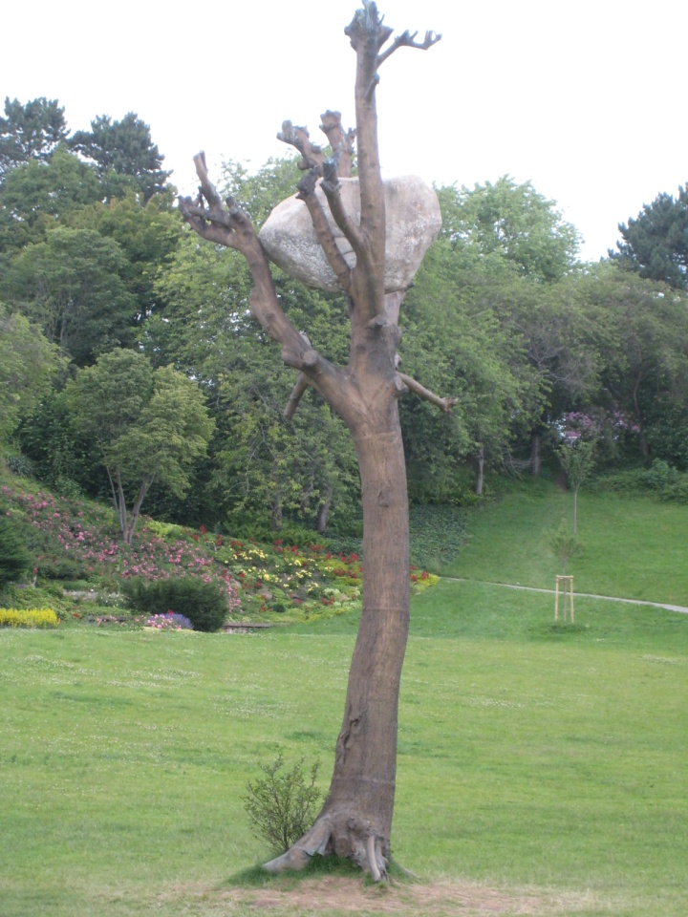 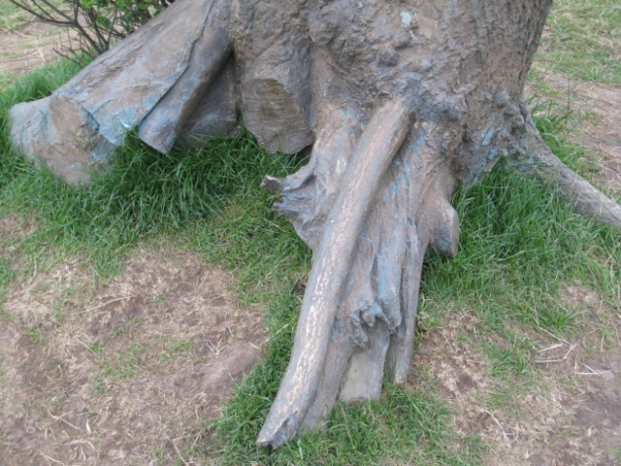

Giuseppe Penone, *Idee di pietra*, 2012 Giuseppe Penone, *Idee di pietra*, 2012 (detail)

In his work *Idee di pietra*, part of *documenta 13* in 2012, Giuseppe Penone presented an *artistic* take on the contemporary entanglements of art and nature. Penone erected a nine meter tall tree in the Karlsaue. However, at first glance it was clear that something was wrong with this tree. It only had a trunk and boughs but no branches or leaves. Moreover, in its bare crown it carried a huge and heavy lump of grey granite. As one approached it, one could see that the tree itself was made not of wood but cast in bronze. The natural proportions had been reversed: the stone was not lying on the ground from which the tree rose but was floating in the height – so above and below were inverted; and what seemed to be a product of nature was in reality a product of art. Penone’s work represents a warning: we must not adhere to the traditional opposition of nature versus art or culture any more. Penone makes tangible the artificiality of contemporary nature.[26]

**Nature invades the museum**

Finally, let us turn to an irritating example: Helmut Wimmer, *The Last Day –* 12 photographic tableaux.

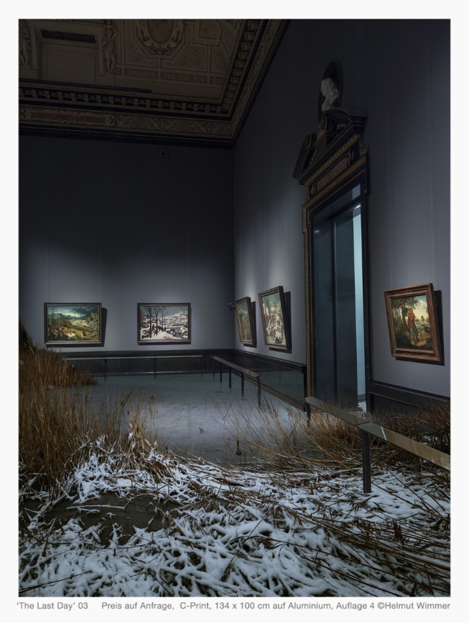 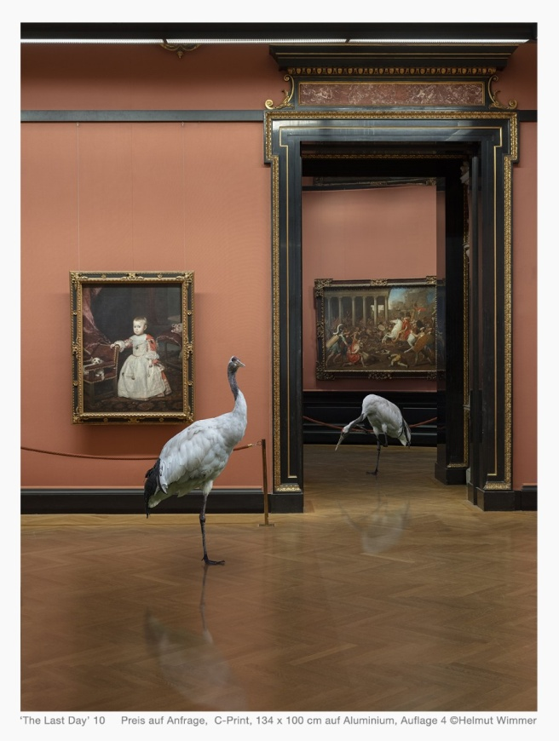

Helmut Wimmer, *The Last Day* 10, 2018, Helmut Wimmer, *The Last Day 03*, 2018,

color print / aluminium, 134 × 100 cm, color print / aluminium, 134 × 100 cm,

Kunsthistorisches Museum Vienna Kunsthistorisches Museum Vienna

We see some familiar interiors of the Kunsthistorisches Museum in Vienna, but something very unfamiliar has happened: they have been invaded by live nature. In the hall with Pieter Bruegel’s *The Hunters in the Snow* brushwood and snow have spread. Cranes strut through other halls and, in a gravitational posture, compete with the Spanish Infanta, or, in a pecking pose, with the turmoil of battle paintings. Elsewhere rocks and a swathe of water burst into a room – yet the museum visitors, oblivious to all this, continue to gaze at the paintings or, their feet having been immersed in water for a while, keep staring at their smartphones. In another room, we can see a huge tree trunk with some boughs and a carpet of leaves – yet the solitary viewer, having failed to register the invasion of nature, remains engrossed in the contemplation of a work of art.

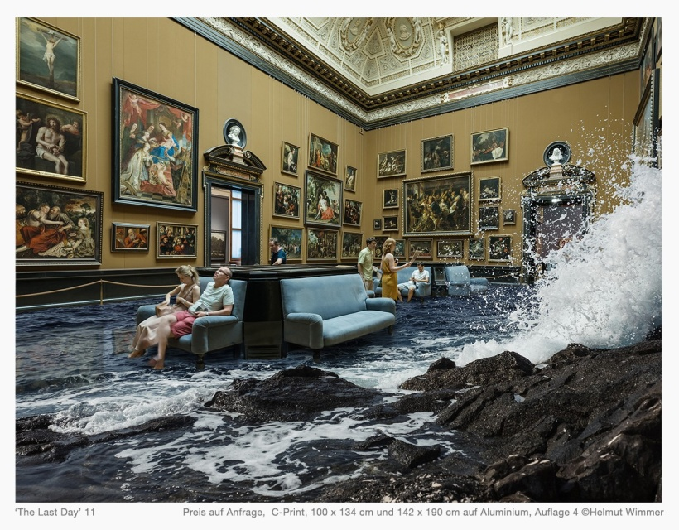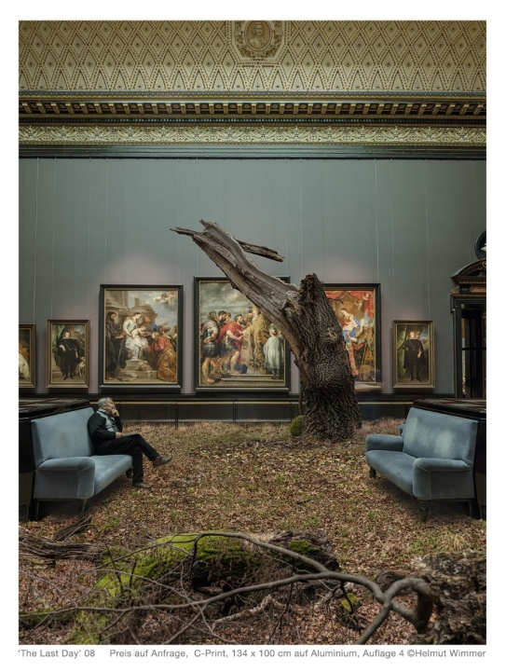

Helmut Wimmer, *The Last Day* 10, 2018, Helmut Wimmer, *The Last Day 03*, 2018,

color print / aluminium, 134 × 100 cm, color print / aluminium, 134 × 100 cm,

Kunsthistorisches Museum Vienna Kunsthistorisches Museum Vienna

After all its fictionalization, nature in its pure form returns into the realm of culture – indeed to an exceptional temple of art. The paintings that hang there have often fed on nature and have shaped our perception of it. But they have also paved the way for some non-perception and oversight, and fostered many a cultural blindness. Now, undomesticated nature returns and, unabashed, enters the sacred halls of art. And people, these cultural beings and art lovers, do not even notice. With all our respect for nature and all our reflection on it, we have become blind to elementary natural phenomena.

This leads us back to the Anthropocene. For this epoch implies not only the human disregard, exploitation and destruction of nature. It could also include – as a consequence and final development – the fall of human culture, which still continues to ignore the signals sent out by nature. And then, in the end, a nature that in no way cares about humans might come to dominate and determine the further fate of this planet.

*// Partly translated by Anda MacBride //*

1. See also Wolfgang Welsch, *Wohin treibt das Anthropozän*?, in: idem, *Wer sind wir?*, New Academic Press, Vienna 2018, pp. 144–163.
2. Pliny the Elder, *Natural History* [*Naturalis historia*, c. 77 A.C.E.], vol. 9, book 35, trans. by H. Rackham, Harvard University Press, Cambridge – Massachusetts – London 1952.
3. For the theoretical argument in favour of this theorem, see Aristotle, *Protrepticus* [II 8]. Its application to the arts is to be found in Aristotle’s *Poetics* [4 and 25].
4. Leone Battista Alberti, *On Painting* [*Della Pictura libri tre*, 1435], trans. with intro. and notes by J.R. Spencer, Yale University Press New Haven 1966, p. 67. ‘It is said, moreover, that in a gem from Pyrrhus all nine Muses, each with her symbol, are to be found clearly painted by nature’ (ibidem).
5. ‘[...] the arts of those who attempt to create images and likenesses from bodies produced by Nature, originated in the following way. They probably occasionally observed in a tree-trunk or clod of earth and other similar inanimate objects certain outlines in which, with slight alterations, something very similar to the real faces of Nature was represented. They began, therefore, by diligently observing and studying such things, to try to see whether they could not add, take away, or otherwise supply whatever seemed lacking to effect and complete the true likeness.’ (L.B. Alberti, *On Painting and On Sculpture: The Latin texts of ‘De pictura’ and ‘De statua’*, ed. with translations, introduction and notes by C. Grayson, Phaidon, London 1972, p. 121).
6. Albrecht Dürer famously stated: ‘For verily, art is embedded in nature; he who can extract it, has it.’ (A. Dürer, *Vier Bücher von menschlicher Proportion*, 1528). Michelangelo reasoned in a similar way, observing that the stone contained all the potential figures, and the sculptor’s job was simply to remove the mass that concealed them so as liberate them (see Michelangelo Buonarroti, *Rime*, Rizzoli, Milano 1954, 77 [LXXXIII]).
7. Marcus Tullius Cicero, *On Invention*, trans. by C.D. Yonge, book 2, part 1, https://en.wikisource.org/wiki/On_Invention/Book_2
8. Aristotle, *Poetics* 25, 1461 b 12–13.
9. This objection is still to be found as late as 1771 in Johann Georg Sulzer‛s *Allgemeine Theorie der Schönen Künste*, part 3, Weidmann, Leipzig 21793, p. 487.
10. Nicholas of Cusa, *Idiota de Mente (The Layman on Mind)* [1450, published in 1488]), in: J. Hopkins, *Nicholas of Cusa on Wisdom and Knowledge*, The Arthur J. Banning Press, Minneapolis 1996, p. 538 [62].
11. Alberti, who had proposed art’s origin in nature, had already proclaimed that art would successively liberate itself from its natural constraints. Even though art was at first inspired by nature, ‛man’s studies in creating likenesses eventually arrived at the stage where, even when they found no assistance of half-formed images in the material to hand, they were still able to make the likeness they wished.’ (L.B. Alberti, *On Painting and On Sculpture*, op. cit., p. 121).
12. ‘Painting represents the works of nature to its sense with greater truth and certitude than do words and letters.’ (Leonardo da Vinci, *Trattato della pittura* [1270], Eng. edition: *Leonardo on Painting: An Anthology of Writings by Leonardo da Vinci with a Selection of Documents Relating to His Career as an Artist*, ed. M. Kemp, selected and trans. by M. Kemp and M. Walker, Yale University Press, New Haven – London 1989, p. 19).
13. E.g. in his *Salons* of 1765 (Eng. edition: *Diderot on Art*, vol. 1: *The Salon of 1765 and Notes of Painting*, ed. and trans. by J. Goodman, intro. by T. Crow, Yale University Press, New Haven 1995) and *Essai sur la peinture* from 1765 (Eng. edition: *Essay on Painting*, in: *Denis Diderot on Art*, vol. 2: *The Salon of 1767*, ed. and trans. by J. Goodman, intro. by T. Crow, Yale University Press, New Haven 1995).
14. Immanuel Kant, *Critique of Judgment*, trans. with intro by Werner S. Pluhar, Hackett Publishing Company, Indianapolis/Cambridge 1986, A 177 [title of § 45].
15. The work was published in 1899–1904 in 10 volumes, and as a complete edition in 1904.
16. Ernst Haeckel, *Preface*, in: *Form Follows Nature: A History of Nature as Model for Design in Engineering, Architecture and Art*, ed. R. Finsterwalder, Springer, Vienna 2011, p. 439. See E. Haeckel, *Art Forms in Nature: The Prints of Ernst Haeckel*, trans. M. Schons, with contributions by O. Breidbach and I. Eibl-Eibesfeldt and a preface by R. Hartmann, Prestel, Munich 2018.
17. Haeckel himself had predicted such an effect: ‘In these true “Art Forms in Nature” modern fine art and the modern, greatly flourishing arts and crafts will find a wealth of new and attractive motifs.’ (E. Haeckel, *Preface*, op. cit., p. 441)
18. For more on this topic, see W. Welsch, *Perspektiven einer evolutionären Ästhetik*, in: idem, *Ästhetische Welterfahrung – Zeitgenössische Kunst zwischen Natur und Kultur*, Fink, Munich 2016, pp. 63–84.
19. By the way, according to Darwin, the first independent (so to speak autonomous) works of art are already being generated within animal aesthetics. In the standard case, the production of beauty takes place in the bodies of one sex, usually the male sex: the males develop ornaments, caprices and all possible aesthetic exuberations (the peacock’s tail springs to mind). But then there is one kind – the bowerbirds – where the males themselves are not at all beautiful, but have shifted their beauty labor from their own bodies to external objects, to bowers: artful creations that serve only to attract a partner and to mate. It is with these bowers, that – after the initial beautification of bodies – the production of independent works of art begins in the animal kingdom.
20. See H.W. Janson, *Apes and Ape Lore in the Middle Ages and the Renaissance*, The Warburg Institute, London 1952, reprint 1976.
21. Reception studies show that people react de facto ‛precisely to those aspects of the environment in which human intentions are revealed’ (Jale Erzen, *Ecology, Art, Ecological Aesthetics*, in: *Ecological Aesthetics: Art in Environmental Design: Theory and Practice*, eds H. Strelow, H. Prigann, V. David, Birkhäuser, Basel 2004, pp. 22–49).
22. The ideology lies in ignoring this cultural formation and taking the factual complexity of nature and culture for nature pure. In fact, Karl Marx was one of the first to note and describe the cultural marking of ‘nature’: ‘nature as it develops through industry, even though in an *estranged* form, is the true *anthropological* nature.’ (K. Marx, (Karl Marx, *Nationalökonomie und Philosophie* [1844], in: idem, *Die Frühschriften*, ed. S. Landshut, Stuttgart: Kröner 1964, pp. 225–316, here p. 245).
23. The culmination of such procedure is that in a garden temple a painting is on show that represents this garden – which was in fact modeled after this representation.
24. Gina Grandell, *Nature Pictorialized: ‘The View’ in Landscape History*, The Johns Hopkins University Press, Baltimore 1993, p. 9.
25. See Konrad Fiedler, *Moderner Naturalismus und künstlerische Wahrheit* [1881], in: ibidem, *Schriften über Kunst*, publ. by G. Boehm, Bd. 1, Fink, München 1991, pp. 81–100. Ironically and with amusing hyperbole, Oscar Wilde described the impact of modern painting on the perception of nature: ‘Nature […] is an imitation of art. […] Nature follows the landscape painter […]. Where, if not from the Impressionists, do we get those wonderful brown fogs that come creeping down our streets, blurring the gas lamps and changing the homes into monstrous shadows? […] The extraordinary change that has taken place in the climate of London during the last ten years is entirely due to a particular school of Art.’ (O. Wilde, *The Decay of Lying: An Observation*, Alma Books, Richmond 2016, pp. 74–75)
26. This is all the more remarkable since the early Penone had been an emphatically sensitive romanticist of nature (compare his *Alberi* from 1969 and 1970).